**Sample *All of Us* Resource Guide**

**What Is the *All of Us* Research Program?**

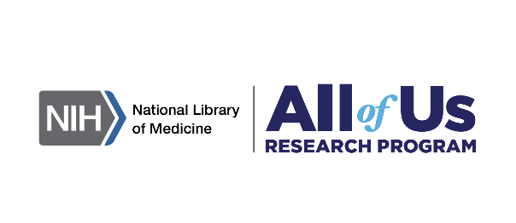

The National Institutes of Health’s (NIH’s) *All of Us* Research Program is building one of the largest biomedical data resources of its kindwith health data from a diverse group of participants across the United States, including people and communities who have been left out of medical research in the past.[1] Data include biological factors and social determinants of health on a large, inclusive scale that tracks participants as they move, age, and grow (longitudinal study design).

Data sources include:

* Electronic Health Records (EHR) standardized using the Observational Medical Outcomes Partnership (OMOP) Common Data Model (CDM)
* Biosamples and bioassays from blood, saliva, and/or urine samples
* Survey responses on identities and backgrounds, overall health, lifestyles, medical histories, healthcare access, experiences with COVID-19, and more
* Physical measurements when joining program
* Heart rate, physical activity, and sleep as tracked by wearable devices[2]

Data now available in the Researcher Workbench
413,350+ Survey responses
337,500+ Physical measurements
312,900+ Genotyping arrays
287,000+ Electronic health records
245,350+ Whole genome sequences
15,600+ Fitbit records
1000+ Long-read sequences

The diverse database, which is a part of the [Precision Medicine Initiative](https://medlineplus.gov/genetics/understanding/precisionmedicine/initiative/), is intended to inform studies on a multitude of heath conditions.[3]

**What Is Precision Medicine?**

Icon representing precision medicine 
Precision medicine is individualized care that considers the environment, lifestyle, family health history, and genetic makeup of a patient. It acknowledges that certain treatments work differently for people with different backgrounds, treats patients as individuals, and can reduce health care costs by providing the right treatment the first time.[4]

Learn more about precision medicine in [this video](https://youtu.be/e_9lXiD5d0c).

**The Researcher Workbench**

All of Us Research how it works graphic 
The Researcher Workbench is a cloud-based platform where registered researchers can access Registered and Controlled Tier data.

Data are curated into three datasets and are available for researchers through the *All of Us* Research Hub and *All of Us* Researcher Workbench.

Learn more about the Researcher Workbench in the [Introduction to the Researcher Workbench video.](https://youtu.be/NTLJtwLcavo)

**The Research Hub**

**Icon representing the multiple tools in the Research Hub
**The Research Hub is public information. Users will need to register in order to gain access to the data and tools in the Researcher Workbench.[5]

**Research Projects Directory**

The [Research Projects Directory](https://www.researchallofus.org/research-projects-directory) includes information about all projects that currently exist in the Researcher Workbench to help provide transparency about how the Workbench is being used.

**Publications**

All [Publications](https://www.researchallofus.org/publications) using *All of Us* data are featured within the Research Hub and can be found under the discover tab.

**Access Tiers**

There are three tiers of data. Your access to these tiers depends on the Data Use Registration Agreement (DURA) your institution has with the *All of Us* Research Program. You can check your institution’s access level [online](https://researchallofus.org/institutional-agreements/).

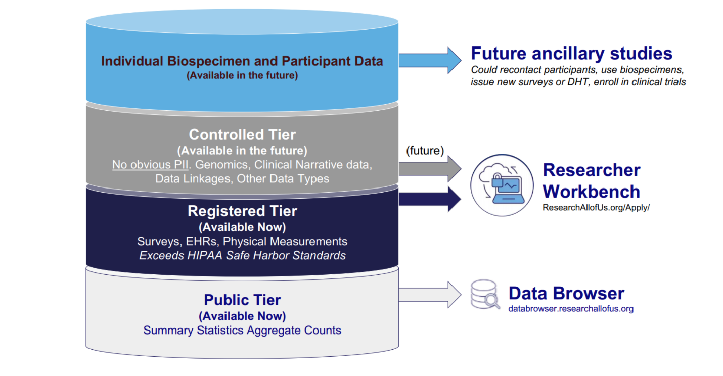

Learn more about the tiers in [this video](https://youtu.be/NC0ku4sQ2sI) and this [slide deck](https://support.researchallofus.org/hc/en-us/articles/6086724990356-All-of-Us-Data-Tiers-101).

**The Public Tier**

The Public Tier data contain only aggregate data with identifiers removed and are available using [Data Snapshots](https://www.researchallofus.org/data-tools/data-snapshots/) and the [Data Browser](https://databrowser.researchallofus.org/).[6] This tier is available regardless of registration status.

**The Registered Tier**

The Registered Tier data contain individual level data from EHRs, wearables, and surveys, as well as physical measurements taken at the time of participant enrollment.[7]

**The Controlled Tier**

In addition to the data in the Registered Tier, the Controlled Tier dataset contains genomic data in the form of whole genome sequencing (WGS) and genotyping arrays, previously suppressed demographic data fields from EHRs and surveys, and unshifted dates of events.[8]

**Researcher Workbench Tools**

Powerful tools in the Researcher Workbench support data analysis and collaboration. 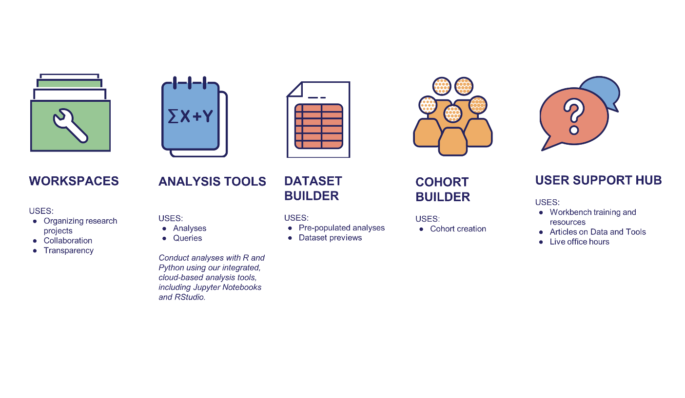

These tools include:

* Shared **Workspaces** to access, store, and analyze data,
* **Notebooks** capable of high-powered queries and analysis using R or Python,
* A **Dataset Builder** to search and save collections of health information about cohorts, and
* A **Cohort Builder** that allows researchers to create, review, and annotate groups of participant data.[9]

**Data Curation**

Details on the [data curation processes](https://www.researchallofus.org/data-tools/methods/?_gl=1*1ha81xz*_ga*MjEwMzY0MjcyNS4xNjcxNTcxNjMw*_ga_7MXT5FNNB6*MTY4ODY2Njk5MC42LjEuMTY4ODY2NzE5NC4wLjAuMA..) are detailed in the Research Hub.

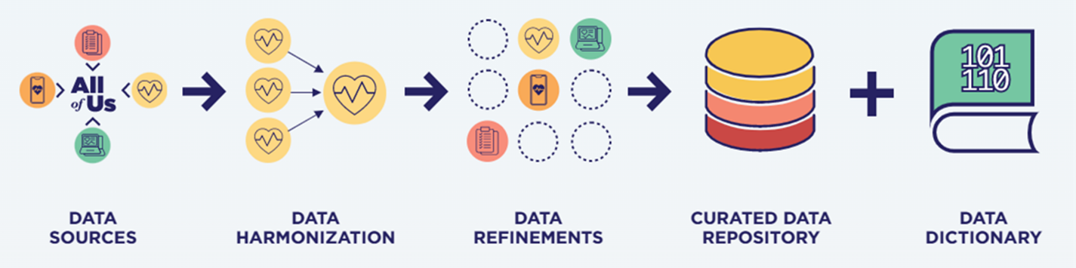

**How to Gain Access**

In order to access the Researcher Workbench Registered and Controlled Tiers, users will need to create a [Researcher Workbench account](https://workbench.researchallofus.org/login) online.

[These instructions](https://www.researchallofus.org/register/) provide a preview of the process.

Registering for access to the Researcher Workbench can be accomplished through four steps.[10]

**Step 1 – Create a Researcher Workbench Account**

Complete your researcher profile, sign the Terms of Service, and agree to the Privacy Policy[11].

**Step 2 – Verify your Identity**

Verify your identity using Login.gov or ID.me. You may need to provide an SSN and a state-issued ID. These are secure services used by participating government agencies.

Researchers who live in the United States, have a social security number (SSN), and have a valid U.S. government-issued ID (e.g., U.S. territory- or state-issued ID) can use login.gov for identity verification. Otherwise, you must use ID.me.

This [article](https://support.researchallofus.org/hc/en-us/articles/4407442809876-Login-gov-Identification-Verification?_gl=1*me2voe*_ga*MTIwOTA4Njc0Ni4xNzAyMzkxNDIz*_ga_7MXT5FNNB6*MTcwMjU3NDkxNC44NS4xLjE3MDI1NzQ5MTcuMC4wLjA.) provide more information on this step.

**Step 3 – Complete the Responsible Conduct of Research Training**

This mandatory training, the [Responsible Conduct of Research Training](https://support.researchallofus.org/hc/en-us/articles/16502340974868-Responsible-Conduct-of-Research-Training-Summary) provides education on conducting responsible and ethical research with data from *All of Us* participants.

**Step 4 – Sign the Data User Code of Conduct.**

The Data User Code of Conduct is an agreement that outlines the program’s expectations for researchers.

A [preview of the agreement](https://www.researchallofus.org/wp-content/themes/research-hub-wordpress-theme/media/data&tools/data-access-use/Data_User_Code_of_Conduct%204.4.2022.pdf) is available online.

**Internal Processes**

**Support Tools and Resources**

**User Support Hub**

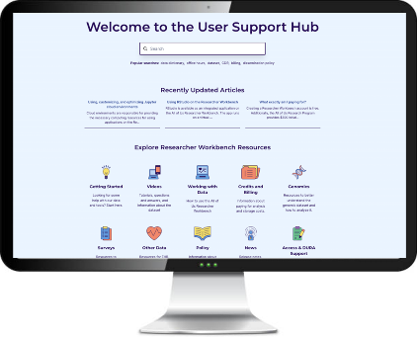The [User Support Hub](https://support.researchallofus.org/) provides a searchable repository for articles and videos answering questions about usage of the Researcher Workbench.

***All of Us* Support Desk**

The *All of Us* Support Desk will assist in resolving technical issues and answer questions. They can be contacted at [support@researchallofus.org](mailto:support@researchallofus.org).

***All of Us* Live Event Calendar**

Weekly office hours are available for registered users and can be found in the [Live Event Calendar](https://support.researchallofus.org/hc/en-us/articles/7360094591124-All-of-Us-Live-Event-Calendar).

**Selected Resources**

* [New User Orientation Video Recording - 5/05/2023](https://youtu.be/BX_t0Ru4Pcc)
* [Getting Started](https://support.researchallofus.org/hc/en-us/categories/360002157352-Getting-Started) with the *All of Us* Support Hub
* [Researcher Workbench Tutorial Videos](https://www.youtube.com/playlist?list=PLR8euOCc1JWjJK_Dy8f5_mWyOk-oH7pug)
* [New to the Researcher Workbench? Start Here!](https://support.researchallofus.org/hc/en-us/articles/12458045951892-New-to-the-Researcher-Workbench-Start-Here-) – An interactive resource map
* [Featured Workspaces](https://support.researchallofus.org/hc/en-us/articles/360059633052-Featured-Workspaces-Table-of-Contents) – Tutorials within the Researcher Workbench

**Coding Resources**

R

* [Using R in the Workbench](https://youtu.be/qvT4YB97LOw) – Office Hours Recording
* [R for Data Science](https://r4ds.had.co.nz/)
* [Teacups, Giraffes, & Statistics](https://tinystats.github.io/teacups-giraffes-and-statistics/index.html)
* [Data Analysis with R Specialization – Coursera](https://www.coursera.org/specializations/statistics)
* [Data Science Specialization – Coursera](https://www.coursera.org/specializations/jhu-data-science)

Python

* [A Whirlwind Tour of Python by Jake VanderPlas](https://jakevdp.github.io/WhirlwindTourOfPython/)
* [Practice Python](https://www.practicepython.org/)
* [Python for Everybody Specialization – Coursera](https://www.coursera.org/specializations/python)
* [Data Analysis with Python – Coursera](https://www.coursera.org/learn/data-analysis-with-python)

**Institutional Support Resources**

**Interactive Apps**

* [*All of Us* Activities](https://www.joinallofus.org/activities)
  + [Hearing](https://www.joinallofus.org/apps/activities/hearing/)
  + [Vision](https://www.joinallofus.org/apps/activities/vision/)
  + [Your Unique Combination](https://www.joinallofus.org/apps/activities/your-unique-combination/)

**Further Reading**

* [*All of Us* Research Hub](https://researchallofus.org/)
* [National Institute of Health *All of Us* Research Program](https://allofus.nih.gov/)
* [Support Hub Video Directory](https://support.researchallofus.org/hc/en-us/categories/5942794068756-Videos)
* [*All of Us* Research Program YouTube Channel](https://www.youtube.com/@AllofUsResearchProgram/featured)

**Other Ideas**

* Feature existing researchers working in the Researcher Workbench.
* Create your own tutorial videos.
* Include bibliography of relevant resources.
* Link to relevant databases, research guides, etc.
* Funding opportunities: [Funding Opportunities | *All of Us* Research Program | NIH](https://allofus.nih.gov/funding-and-program-partners/funding-opportunities)
* Subject Specific Resources
* Gallery of Data Visualizations
* Calendar of upcoming trainings or events related to *All of Us*
  + Weekly office hours are available for registered users and can be found in the [Live Event Calendar](https://support.researchallofus.org/hc/en-us/articles/7360094591124-All-of-Us-Live-Event-Calendar).
  + Internal trainings to each institution.
* Directory of local contacts, availability
* Designated computer availability, location, and access instructions
* Research Testimonials – Existing videos from *All of Us*
  + [Building a Transparent and Inclusive Research Community](https://youtu.be/AoFdKiS8l8s?si=BhD0BT0tHAUw3Sng)
  + [Meaningful Inclusion of LGBTQ+ People in Research](https://youtu.be/5xBdnEC4kiE?si=rRL5CvKOW1OC5qtj)
  + [Understanding the Behavioral Health Needs of People with HIV](https://youtu.be/jeXVHKH8lRo?si=CzoyV6CX-C6T93YH)
  + [Advancing Women's Health Research](https://youtu.be/NRqU4qeIFsE?si=FcRkk-C_-s-UnoSP)
  + [Advancing Research in Underrepresented Communities](https://youtu.be/KaDn6VUxdJI?si=iS29ZpmazUk063ki)
  + [The *All of Us* Research Program advances medical genetics](https://youtu.be/MiQIF4GRnxs?si=ShUMmzFGc3cdvaXF)
  + [Predictive Analytics for Glaucoma: A project powered by the *All of Us* Research Program](https://youtu.be/mKGusIyKaCM?si=C5u1TQDXgsVZRbr-)
  + [How diverse data can power more impactful research](https://youtu.be/NC-QICzBJB0?si=Q4USX9UzRE2kiyzN)
  + [Studying health care access and utilization among adult cancer survivors](https://youtu.be/O4e06PhthsA?si=RCpjmxDDkFdN80NC)

1. (Welcome to the All of Us Research Hub, 2023)
2. (Data Sources, 2023)
3. (Health, 2021)
4. (Health, 2021)
5. (Opportunities for Researchers, 2023)
6. (Data Access Tiers, 2023)
7. (Data Access Tiers, 2023)
8. (Data Access Tiers, 2023)
9. (Researcher Workbench, 2023)
10. (Register to Be an All of Us Researcher, 2023)
11. (Register to Be an All of Us Researcher, 2023)